SANKOFA Eco-Cultural Tours

Tobago: A Slice of Paradise, April 9-16, 2020
Rainforest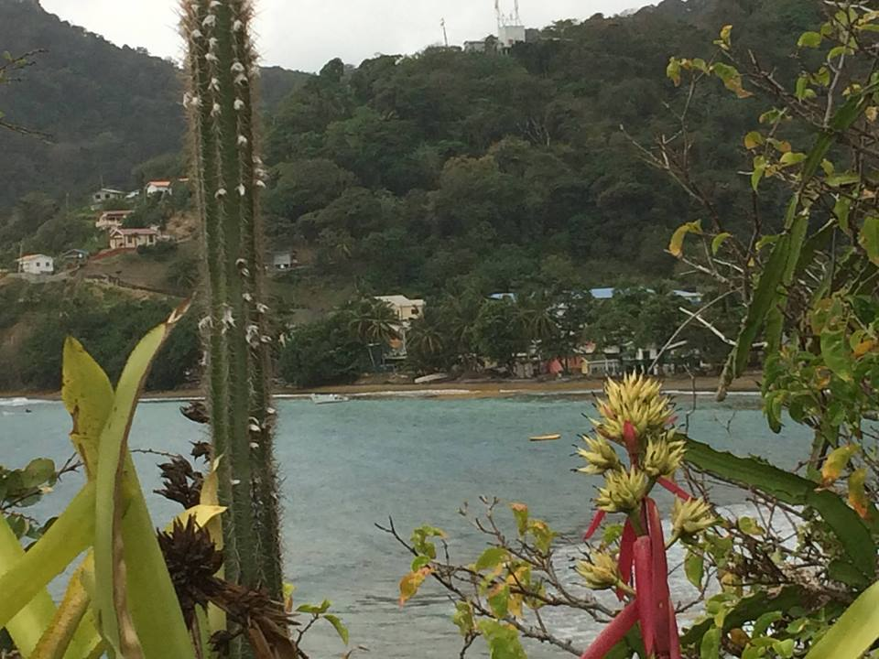Speyside, Tobago
Day 1 – Morning Yoga & Stretching w/Bathe (Swim) in the Sea - R&R in pm.
Day 2 – Reef Boat & Nylon Pools Tour
Day 3 – FREE Day w/Options Provided
Day 4 – Island Tour & Rainforest Jaunt
Day 5 – FREE Day w/Options Provided
Day 6 - Pigeon Point Beach Party - R&R in pm
Day 7 – Trinidad Arima Valley Rainforest (Asa Wright Nature Center)
Day 8 – Departure

Soul Quests: Vision Quests For the Soul
Mound Trekking: Southeastern Ceremonial Complexes, May 28-June 4, 2020

Day 1 – Arrive ATL – HOTEL – R&R - PPT Presentation
Day 2 – Etowah Mound Tour w/Overnight Stay
Day 3 – Brasstown Bald & Track Rock Gap w/Overnight
Day 4 – Tellus Science Center w/Planetarium Visit
Day 5 – Return Atlanta - HOTEL/R&R
Day 6 – Stone Mountain/Ocmulgee Mound w/Overnight
Day 7 – Eagle Rock Effigy Mound w/Special Dinner Party
Day 8 – Departure

Sankofa Eco-Cultural Tour Registration Form:

Name:

Address:
City/State/Zip:
Phone#: What’sApp#:
Email:

Tour Selection:
tobago, April 9-16, 2020 Mound Trekking, May 28-June 4, 2020

Amount Paid:
Special Requests/Questions:

2020 SANKOFA Eco-Cultural Tours Payment Plan:

Tobago Island Tour - Total: $2750.00/US (Can be made in one payment)
20% Down payment of $550.00 Due Upon Registration/December 1, 2019
with 4 monthly payments of $550.00 w/last payment due by April 1, 2020

Mound Trekking Tour – Total: $2550.00/US (Can be made in one payment)
20% Down payment of $510.00 Due Upon Registration/December 10, 2019
with 4 monthly payments of $510.00 w/last payment due by April 10, 2020

Payments can be made via Paypal to:
sufia.giza@gmail.com
www.moundbuilderswindclan.com/shop
803.743.7970/US (WhatsApp/iPhone)
868.327.9683/T&T (WhatsApp)

20% deposit of registration processing fee is non-refundable

SANKOFA Eco-Cultural Tours
Journey with Veteran Traveler & Herbalist, SUFIA GIZA, on an Eco-Cultural Tour to the island Paradise of Tobago, WI., or Mound Trekking in the Southeastern Ceremonial Complexes.
Ms. Giza has cruised both the Pacific and Atlantic Oceans, visiting such places as Puerto Vallarta, Acapulco and Cozumel, Mexico, as well as other exotic destinations in the Caribbean including, Trinidad & Tobago, Dominica, Guadalupe, St. Thomas, Granada, Bermuda, Venezuela, Curacao, Jamaica, St. Marten and Barbados. Sufia’s a true ‘Globe Trotter’, having also traveled to Belize, Central America and Egypt, Africa. She has been visiting the beautiful country of Trinidad & Tobago for 28 years and has been Mound Trekking in the Southeast since 2010.

Tobago, A Slice of Paradise:, April 9-16, 2020
Enjoy 7 days in Paradise, filled with Healing & Adventure. Visit a tranquil Waterfall in the Rainforest, or take a bathe (swim) in the Sea to start your day. Energize with morning Yoga at the Beach and eat fresh local food, including fish right out the Sea. From Jet-Skiing to Snorkeling or Scuba Diving, there’s numerous Water Sports, or simply relax on a Reef Boat trip to the Nylon Pools. SUNDAY School is a must…... Lastly, we end our tour under the canopy in the Arima Valley Rainforest at Asa Wright Nature Center.

Mound Trekking in the Southeast:, May 28-June 4, 2020
Enjoy 7 days venturing into the Southeastern Ceremonial Complexes of Ancient American Mississippian Moundbuilders. Visit Historical Archeological Sites. Climb ancient mounds. Hike trails. Explore museums to see artifacts and experience the mystery of this ancient civilization first-hand. We’ll also journey to Stone Mountain Park in Atlanta and visit an ‘Animal Effigy’ Mound. Our last night includes a special Dinner Party with home cooked food and music.

